Not a safe practice!

Operating a motor vehicle safely requires concentration, focus and awareness of constantly changing surroundings. Talking on a cell phone can take your focus away from the road and increase the risk of accidents. On average, a person is four times more likely to be in an accident when talking on a cell phone.

State laws regarding driving with cell phones: More and more states have passed laws that prohibit hand-held cell phone usage while driving. Check with your local jurisdictions to determine if any cell phone restriction laws are present.

Important guidelines: Regardless of your state, a comprehensive cell phone policy should be included in your organization’s fleet safety program. At a minimum, the following guidelines can be included into your organization’s fleet safety program:

- Get your phone set-up to be legal and safe: Every cell phone manufacturer creates different devices to use in a hands-free manner. It is important to know how to program your speed dial, operate the speakerphone, voice activation, redial features and other safety functions.
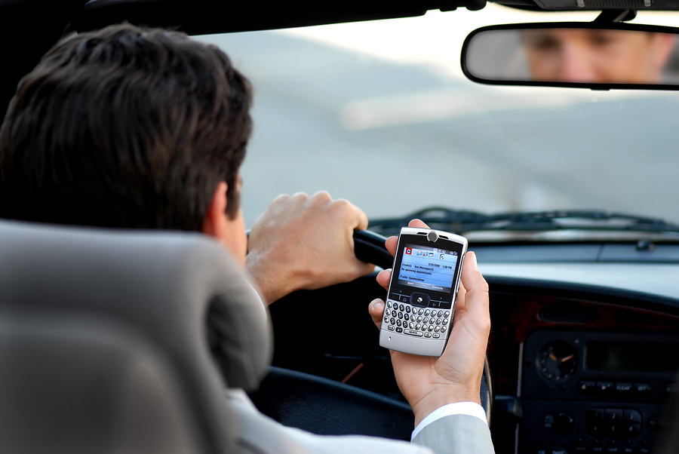

- Have someone else make the calls: If passengers are present, allow them to answer and dial calls for you.

- Use a hands-free device with your cell phone: Hands-free cell phone accessories are readily available. Whether you choose an installed mounted device for your cell phone or a speaker phone accessory, take advantage of these devices. Assure it is safe and legal!

- Do not multi-task with your phone when driving: Never text message or take down notes when the vehicle is in motion. These types of activities are serious distractions and increase your risk of an accident.

- Use your voice mail: Allow phone calls to go to voice mail, and return calls when you reach your destination.

- Pull the vehicle over: If you must make or receive a call, pull your vehicle over to a safe and legal location before making or answering a phone call.

- Do not use your phone in poor conditions: Poor driving conditions or low light situations can severely affect your reaction and response time. Using a cell phone when driving at night or in rainy situations is not recommended.

This form documents that the training specified above was presented to the listed participants. By signing below, each participant acknowledges receiving this training.

Organization:

Trainer: Trainer’s Signature:

Class Participants:

Name: Signature: Date:

Name: Signature: Date:

Name: Signature: Date:

Name: Signature: Date:

Name: Signature: Date:

Name: Signature: Date:

Name: Signature: Date:

Name: Signature: Date:

Name: Signature: Date:

Name: Signature: Date:

Name: Signature: Date:

Name: Signature: Date:

Name: Signature: Date:

Name: Signature: Date:

Name: Signature: Date:

Name: Signature: Date:

Name: Signature: Date:

Remember to load your completed trainings into the Training Track application of the Risk Management Center.

