Objective: To communicate requirements for working with solvents in the workplace.

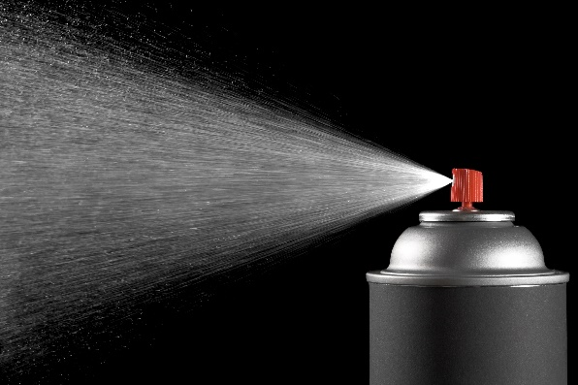
Understanding Solvents
A solvent is a compound that dissolves another substance, creating a solution. Common solvents in most workplaces are organic materials such as paint thinners, degreasers, alcohols, and petroleum distillates. These solvents can present significant danger as they evaporate into the air in confined or poorly ventilated areas.
In general, solvents are clear, liquid, and often have a characteristic odor. There are two major types of solvents – chlorinated and
non-chlorinated.
- Chlorinated solvents are organic compounds that have a chlorine atom attached. This chemical composition makes most of them
non-flammable, which is good for many industrial applications. However, they decompose when exposed to heat, producing toxic fumes.
Many cleaning and degreasing solvents can be found in aerosol form.
  - Examples include chloroform, methylene chloride, and trichloroethylene.
- Non-chlorinated solvents are organic compounds with no chlorine atom attached. Most non-chlorinated solvents are flammable. They are typically considered more environmentally friendly than chlorinated solvents.
  - Examples include chemicals such as acetone, toluene, and isopropyl alcohol.
Requirements for Working with Solvents
Employees who work with solvents should have appropriate training to understand the hazards, including hazard communication training. Note: This training short is not a substitute for hazard communication training. Only work with solvents when using proper hazard controls and wearing personal protective equipment (PPE). You are expected to follow your workplace’s hazard communication procedures, including having safety data sheets (SDSs) available and any other applicable safety procedures based on the scope of work.
Certain solvents may have additional restrictions for use, storage, and disposal based on their chemical properties. In particular, the U.S. Environmental Protection Agency (EPA) sets regulations for the use of certain solvents, such as methylene chloride, or operations using solvents, such as spray coating and refinishing, to reduce hazardous air emissions. Check your state/local regulations in addition to any federal regulatory requirements for working with solvents.
Health Hazards
Solvents exist in many workplaces, even those that may not be conventionally hazardous. Because they are so common, users can become complacent about their health hazards. However, they can cause serious or even fatal effects.
- Exposure to skin can cause irritation symptoms such as cracking or dermatitis. However, absorption through the skin can also result in internal damage.
- Solvent vapor can irritate eyes and breathing passages, e.g., noses, throats, or lungs.
- Some solvents may displace breathing air, making the environment dangerous.
- Long-term exposure may be harmful to the liver, kidney, lungs, eyes, and nervous system and can cause cancer.
Permissible Exposure Limits
The U.S. Occupational Safety and Health Administration (OSHA) establishes permissible exposure levels (PELs) for solvents in the workplace to help reduce potential exposures to hazardous concentrations of chemicals.
- PELs tell you about the amount of a chemical to which you can be exposed over an 8-hour workday without experiencing adverse health effects.
- If air monitoring determines that these exposure levels are high enough to meet the action level of the PEL or greater, then your workplace will implement controls to reduce exposure levels.
- If controls cannot reduce exposure levels (or if the product SDS requires it), then appropriate respirators must be used to protect the user from harmful concentrations of a solvent.
Hierarchy of Controls
When working with hazardous chemicals, like solvents, it’s always best to consider how to eliminate or reduce exposure levels. Using the hierarchy of controls can help efficiently consider options for minimizing exposure. Consider these steps:

- Eliminate the use of solvents where possible. Can you change an operation so that you don’t need the product?
- Substitute them for less hazardous alternatives. Can you use a product that is less volatile or non-toxic?
- Engineer them out of a process. Enclose the workspace, provide ventilation, etc. What can you do to minimize or eliminate employee contact?
- Use administrative controls such as training, work rotations, and standard operating procedures to minimize exposure. How can you change the work to minimize exposure? What information will be helpful to the worker?
- Wear PPE to protect from remaining hazards. What is required to protect the worker?

PPE Considerations
Your PPE needs may vary depending on the solvent you are using. Always check the SDS for specific exposure controls.
- Check the glove manufacturer’s chart to choose gloves with the appropriate chemical resistance.
- Contact with solvents will degrade PPE over time. Inspect PPE before use and replace it as needed.
- Follow all requirements for use as set forth in OSHA’s Respiratory Protection Standard if required to wear a respirator.
- Choose appropriate eye, face, and body protection based on the solvent and type of work you’ll be performing. Consider splashback, vapor exposure, and other hazards that may expose your skin, eyes, or extremities.

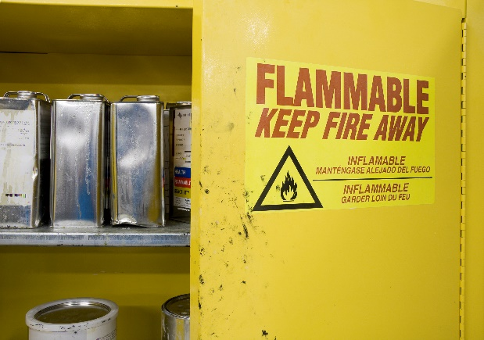
Control Ignition Sources
To prevent fires, ensure that all ignition sources are controlled. Do not use solvents on hot surfaces.
- Use and store solvents in areas free from sources of ignition, sparks, open flames, and oxidizers (such as calcium hypochlorite, sodium nitrate, or peroxides).
- Make sure that containers are tightly closed when not in use.
- Use appropriate bonding and grounding methods when transferring flammable liquids from one container to another to prevent static buildup.
Safe Handling Tips
Store solvents in designated flammable liquid storage rooms, cabinets, or lockers.
If you have any questions on safe solvent use, review your standard operating procedures and contact your supervisor.
- Use a solvent only for its intended purpose; do not use any solvents for unauthorized applications. NEVER use solvents to rinse or wash your hands.
- Keep solvent containers closed when not in use to avoid breathing the solvent vapors.
- Always position dispensing nozzles, spouts, or other openings for decanting solvents away from your face and body.
- Be aware of hazardous vapors, especially when working in unventilated or confined spaces.

This form documents that the training specified above was presented to the listed participants. By signing below, each participant acknowledges receiving this training.

Organization: Date:

Trainer: Trainer’s Signature:

Class Participants:

Name: Signature:

Name: Signature:

Name: Signature:

Name: Signature:

Name: Signature:

Name: Signature:

Name: Signature:

Name: Signature:

Name: Signature:

Name: Signature:

Name: Signature:

Name: Signature:

Name: Signature:

Name: Signature:

Name: Signature:

Name: Signature:

Name: Signature:

Name: Signature:

Name: Signature:

Name: Signature:

Name: Signature:

