In cold, wet conditions, common dangers include slips and falls, as well as vehicle accidents. Taking simple precautions can prevent accidents and injuries.
Preventing slips:
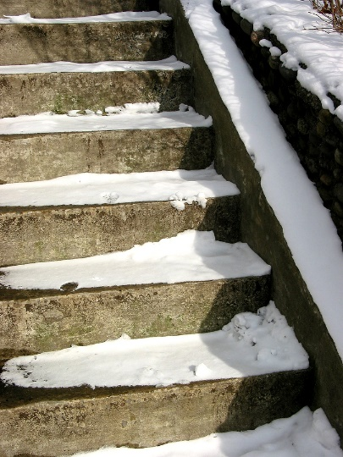
Areas that may become slick and require extra caution include stairs, ramps, tile floors, parking lots and metal parts of equipment.
- Have an excellent snow and ice removal program in place.
- Place non-skid floor mats and caution signs in slippery, high traffic areas.
- Use traction devices that strap onto shoes when conditions require them.
- Use the right shoes. Anti-slip soles are essential. Shoe soles need to have thin cuts, often called siping, that disperse water and grip the ground.
Driving safety:
- Slips can happen when entering and exiting your vehicle, so be cautious. Use a three-point stance when getting in and out of your vehicle. Use a grab-bar or doorframe for stability.
- Be aware that the vehicle itself can lose traction, causing uncontrolled skids.
- When roads are slick, slow down, leave extra following distance between yourself and other cars and do not make sudden vehicular movements.
- If you begin to skid, turn the wheel in the direction you want the vehicle to go. Ease your foot off the accelerator, and do not hit the brakes.
- Know the weather conditions you will encounter and plan ahead.
- Inspect your vehicle for proper tires and other winter driving gear.
- Be sure that chains and cold weather gear are on board and ready for use.
- Assume that roads, bridges and exits are icy, and be ready for them.
- Keep lights, windows and mirrors clean. This is especially important in low visibility situations such as darkness, ice or fog.
- If pulling over due to an emergency, increase your visibility to passing traffic. Activate the vehicle’s hazard warning lights, wear your safety vest, set up a warning triangle or flares and assume that ongoing traffic does not see you.
Remember, ice is twice as slippery at 30˚F as at 0˚F.

This form documents that the training specified above was presented to the listed participants. By signing below, each participant acknowledges receiving this training.

Organization: Date:

Trainer: Trainer’s Signature:

Class Participants:

Name: Signature:

Name: Signature:

Name: Signature:

Name: Signature:

Name: Signature:

Name: Signature:

Name: Signature:

Name: Signature:

Name: Signature:

Name: Signature:

Name: Signature:

Name: Signature:

Name: Signature:

Name: Signature:

Name: Signature:

Name: Signature:

