Combustible dust is defined as a solid material composed of distinct particles which present a fire hazard when suspended in air. A dust explosion can cause catastrophic loss of life, injuries, and destruction of property.

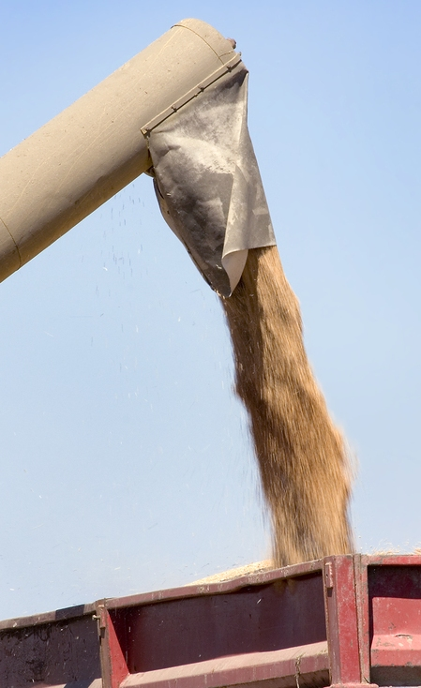
Characteristics of a dust explosion:
- Definition: A dust explosion can be defined as a rapid release of high pressure gas into the environment.
- Process:
- It commonly begins with the ignition of a fuel, such as a combustible dust, that burns very rapidly.
- It produces a large and sudden release of gas and does not necessarily involve a fire.
- There are often more serious secondary explosions that result from an initiating explosion
which dislodges loose particulates.
- Five criteria that must be present for dust explosion conditions:
- Fuel, i.e., combustible dust
- Heat or an ignition source
- Oxygen, which may be in the form of an oxidizer chemical
- Dispersion of dust particles of a certain concentration and quantity
- A confined dust cloud
Examples of industries where combustible dusts are common:
- Grain handling
- Flour production
- Industries using wood
- Sugar manufacturing
- Certain types of plastic
- Coal handling
- Textile industries using cotton, nylon, etc.
- Metal production such as aluminum, sodium, and potassium

Fighting dust accumulation:
Assure that dust-containing systems, ducts, and dust collectors are designed in a manner that prevents fugitive dusts from accumulating in the work area. This includes proper air velocity and enough volume in the dust collectors for the various applications.
  - Assure that the working surfaces are designed in a manner to minimize dust accumulation and to facilitate cleaning.
  - Accumulations on overhead beams, joists, ducts, the tops of equipment, and other surfaces must be included when assessing dust concentrations.
  - Your facility must have a housekeeping program with regular cleaning frequencies established for floors and horizontal surfaces, including ducts, pipes, hoods, ledges, and beams, to minimize dust accumulation within operating areas of the facility.
  - Housekeeping practices must include immediate cleaning whenever a dust layer of 1/32-inch thickness accumulates over a surface area of 5% or more of the floor area of the facility or any given room.
- If the floor area exceeds 20,000 ft², a dust layer must not exceed a 1,000 ft² floor area.
Controlling heat and ignition sources:
- Electrical equipment must meet Class II requirements for explosion proof control. This includes electrically-powered cleaning devices such as vacuum cleaners.
- An effective ignition control program must be in place.
- Include in the program such elements as grounding and bonding, metal detection, preventive maintenance programs, and other methods.
- An effective program will dissipate any sparks or electrostatic charge that could be generated where a combustible atmosphere may exist (e.g., in ductwork).
- Implement a hot work permit program.
- Post and enforce no smoking areas.
- Assure that duct systems, dust collectors, and dust-producing machinery are bonded and grounded to minimize accumulation of static electrical charge and equipped with spark detection and arrest systems.
- Use industrial trucks, machinery, and electrical equipment that are approved for Class II combustible dust locations.

Follow these control measures to avoid dust build-up and prevent dust explosions.

This form documents that the training specified above was presented to the listed participants. By signing below, each participant acknowledges receiving this training.

Organization: Date:

Trainer: Trainer’s Signature:

Class Participants:

Name: Signature:

Name: Signature:

Name: Signature:

Name: Signature:

Name: Signature:

Name: Signature:

Name: Signature:

Name: Signature:

Name: Signature:

Name: Signature:

Name: Signature:

Name: Signature:

Name: Signature:

Name: Signature:

Name: Signature:

Name: Signature:

