It’s cold outside! Are you ready?
Weather can often be unpredictable and extreme, causing unseen risks and situations. In such temperamental weather, extreme freezing temperatures can create serious health problems.
- Near freezing weather and strong winds can cause a person to lose body heat much quicker than normal.
- These two drastic weather conditions are the two major factors that lead to “cold stress.”
- The symptoms of cold stress are brought on by exposure when working long periods of time in extreme cold, or when working in poorly insulted or heated areas.
- Those that are unaccustomed to freezing weather are more likely to experience cold stress.
- Below are a few possible symptoms of cold stress to watch out for!
Hypothermia:
- The body cannot create enough heat to keep itself warm during long periods of time spent in freezing weather.
- After our body runs out of stored energy it results in an abnormally low body temperature. This is when hypothermia can cause some serious problems.
- The brain can be affected, making it difficult to think clearly or move well.
- Most people are unaware that they are even being affected by hypothermia until serious problems occur.
Frostbite:
- Unlike hypothermia, frostbite is an injury to the outside of your body and is a symptom of freezing temperatures.
- After lengthy exposure to freezing weather the victim may lose feeling and color in the affected areas.
- Frostbite most often affects the extremities; i.e., nose, ears, cheeks, chin, fingers, or toes.
- Damage can permanently destroy body tissue and in worse case scenarios lead to amputation.

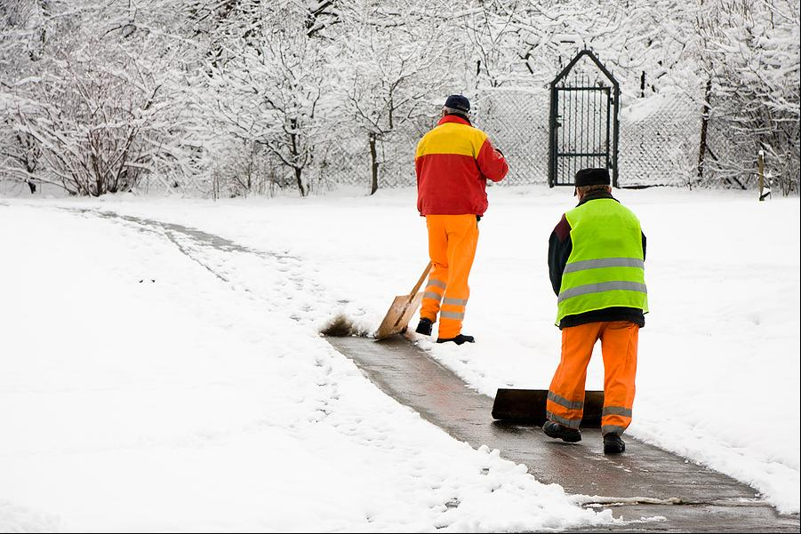

Trench Foot:
- Trench foot, also known as immersion foot, is an injury that can happen in temperatures as high as 60 (ºF).
- Immersion foot is when a person’s feet are exposed to wet and cold conditions for extended periods of time. Wet feet lose heat 25 times faster than dry feet, which is why this injury can be so severe.
- When the body attempts to save heat it constricts blood vessels and circulation to the feet slows down.
  - The lack of blood flow, oxygen, and nutrients to the foot can cause the skin to die.
Chilblains:
- Chilblains, also known as “Pernio” and “Perniosis” is another cold stress issue and can be caused by temperatures between freezing and 60 (ºF).
- Chilblains are caused by repeated prolonged exposure of skin to cold temperatures.
- It can cause permanent damage to the capillary beds in the skin.
  - This could lead to reoccurring redness and itching when exposed to cold weather.
- It often affects the body’s extremities; e.g., face, hands, ears, as well as any areas that are unprotected from cold temperatures.
Protect your employees! Follow these helpful tips to prevent cold stress from affecting workers:
- When scheduling repairs and maintenance consider the month of the year and time of day. Schedule cold jobs for warmer times.
- Reduce the physical demands by assigning additional workers for extra long and demanding jobs.
- Set up a warm area with warm beverages for workers to take breaks and rest.
- Monitor and train workers who are at risk for cold stress. Give them information about inherent risks, prevention, symptoms, available treatment, and required personal protective equipment.
Recommendations for workers: Stay warm and safe by following a few helpful tips:
- Wear appropriate clothing, such as wearing multiple layers of loose clothing.
- Protect the ears, face, hands and feet in extreme cold weather by wearing a hat and waterproofed and insulated boots.
- During breaks move to a warm area and limit your time outside.
- Always carry cold weather gear, such as extra socks, gloves, hats, jackets, blankets, change of clothes and a thermos of hot liquid.
- Avoid touching cold metal surfaces with bare skin.
- Be aware and monitor yourself and your coworkers for signs of cold stress.

This form documents that the training specified above was presented to the listed participants. By signing below, each participant acknowledges receiving this training.

Organization:

Trainer: Trainer’s Signature:

Class Participants:

Name: Signature: Date:

Name: Signature: Date:

Name: Signature: Date:

Name: Signature: Date:

Name: Signature: Date:

Name: Signature: Date:

Name: Signature: Date:

Name: Signature: Date:

Name: Signature: Date:

Name: Signature: Date:

Name: Signature: Date:

Name: Signature: Date:

Name: Signature: Date:

Name: Signature: Date:

Name: Signature: Date:

Name: Signature: Date:

Name: Signature: Date:

Remember to Load Your Completed Trainings into the Risk Management Center.

