What are Safety Data Sheets (SDSs)?
Safety Data Sheets are written or printed materials with information about hazardous chemicals. These documents are provided by the manufacturer or importer of the chemical. They include what chemicals are in a product, the physical and health hazards of those chemicals and what steps must be taken to prevent adverse effects when using the product.

Safety Data Sheets and the Hazard Communication Standard: The Hazard Communication Standard requires a written hazard communication program to be in place. This written program requires:
- SDSs to be obtained and accessible for all chemicals used in the workplace.
- A chemical inventory list.
- Training for all employees to assure they know:
- How to read and understand the SDSs.
- The health and physical hazards of the materials they could be exposed to.
- The proper controls to safely handle the chemicals used.

The contents of a SDS:
When a chemical manufacturer or importer prepares a SDS, it must have 16 headings or sections as outlined below. These sections correspond with the international requirements established by the Globally Harmonized System of Classification and Labeling of Chemicals (GHS). The standardized format provides uniformity around the world.

Listed are the 16 sections with a brief description of what is required in each section:

- Section 1: Identification
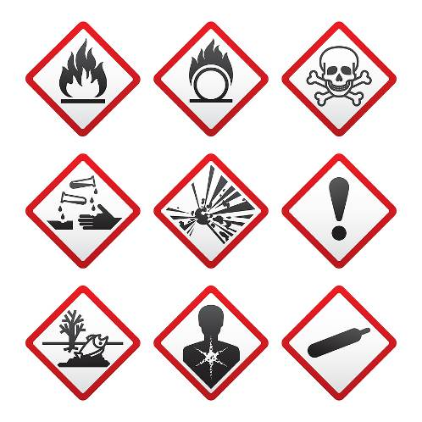
- Product identifier, recommended use, restrictions of use and contact information of the manufacturer.
- Section 2: Hazard identification
- Pictograms, hazard statements, signal words and precautionary statements.
- Section 3: Composition
- Ingredients, chemical name, common name, and Chemical Abstract System (CAS) number.
- Section 4: First aid measures
- Description of necessary measures specific to the method of exposure
- Section 5: Fire fighting measures
- Suitable extinguishing media specific to hazards arising from the chemicals.
- Section 6: Accidental release measures
- Personal precautions to take, Personal Protective Equipment (PPE), containment and cleanup procedures.
- Section 7: Handling and storage
- Precautions for safe handling.
- Section 8: Exposure controls
- Permissible exposure limits (PEL) and appropriate engineering controls.
- Section 9: Physical and chemical properties
- Includes but is not limited to appearance, odor, melting point, pH and flash point.
- Section 10: Stability and reactivity

- Reactivity, chemical stability and conditions to avoid.
- Section 11: Toxicological information
- Health effects, information on routes of exposure, symptoms related to chemical, physical and toxicological characteristics.

- Section 12: Ecological information
- Degradability and bioaccumulative potential.
- Section 13: Disposal considerations
- Safe handling of waste residue.
- Section 14: Transport information
- Proper shipping name and transport hazards.
- Section 15: Regulatory information
- Safety, health and environmental regulations.
- Section 16: Other information
- Date of preparation and date of last revision.
Sections 12 through 15 are included to be GHS compliant but will not be enforced by OSHA.

Always refer to the applicable Safety Data Sheet when using chemicals.
It can keep you and your co-workers safe.

This form documents that the training specified above was presented to the listed participants. By signing below, each participant acknowledges receiving this training.

Organization: Date:

Trainer: Trainer’s Signature:

Class Participants:

Name: Signature:

Name: Signature:

Name: Signature:

Name: Signature:

Name: Signature:

Name: Signature:

Name: Signature:

Name: Signature:

Name: Signature:

Name: Signature:

Name: Signature:

Name: Signature:

Name: Signature:

Name: Signature:

Name: Signature:

Name: Signature:

