Ensuring a safe work environment is a duty that all workers and management share.
The safety of those working around you is in your hands. Unsafe choices that you make can injure both you and your coworkers. Everyone needs to take safety seriously, or everyone is at risk.
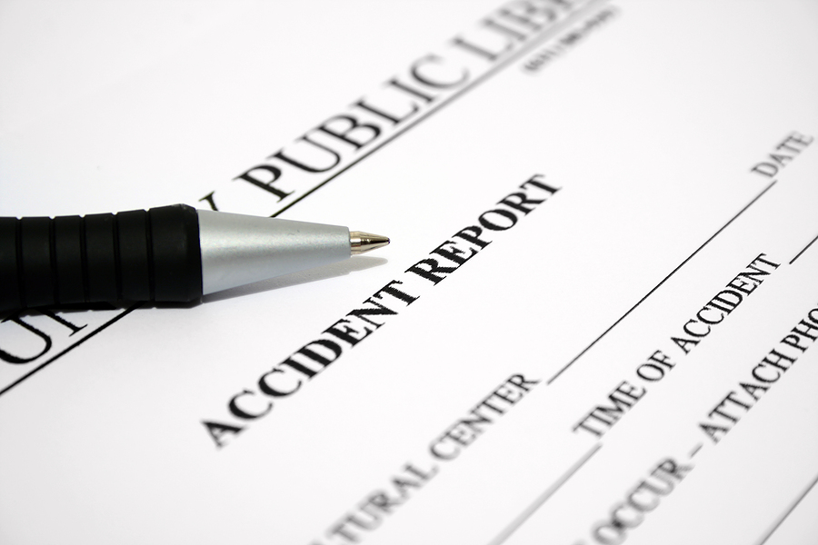
Your coworkers and you are the first line of defense against workplace incidents. You are provided with the training and equipment to do your job safely, but it is up to you use safe practices every day.

Take an active role in keeping your workplace safe.
- Learn about the safety programs of the organization.
- Learn the proper techniques to safely perform any job assigned to you.
- Help your coworkers learn and use safe practices.
- Respect guards, locks, tags and other safety devices that you come across. Report all missing and damaged devices.
- Only use the tools and equipment you are trained and authorized to use. Use them only for their intended purposes.
- Only use chemicals you are trained and properly equipped to use.
- Don’t take unnecessary risks.
- Report any dangerous behavior immediately.
- Report any hazardous conditions immediately.
- If you are unsure about the safety of a situation, contact your supervisor.
More than your own safety is at stake.
This form documents that the training specified above was presented to the listed participants. By signing below, each participant acknowledges receiving this training.

Organization:

Trainer: Trainer’s Signature:

Class Participants:

Name: Signature: Date:

Name: Signature: Date:

Name: Signature: Date:

Name: Signature: Date:

Name: Signature: Date:

Name: Signature: Date:

Name: Signature: Date:

Name: Signature: Date:

Name: Signature: Date:

Name: Signature: Date:

Name: Signature: Date:

Name: Signature: Date:

Name: Signature: Date:

Name: Signature: Date:

Name: Signature: Date:

Name: Signature: Date:

Remember to load your completed trainings into the Risk Management Center.

