When handling knives, box cutters, or machines and tools with blades, take care to protect yourself from cuts. Cuts from knives may occur as a result of improper handling, improper storage, or the accidental dropping of knives. To prevent injury, apply the following approaches.
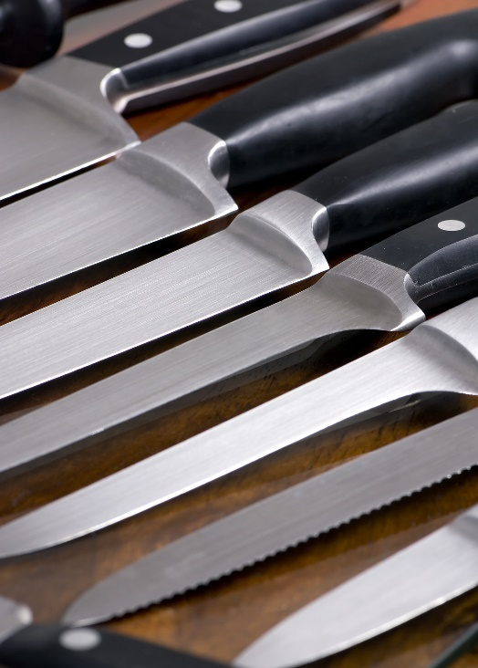
Planning:
- Assess tasks to identify the potential hazards and appropriate personal protective equipment (PPE).
- Require employees to use appropriate controls and hand protection when exposed to hazards such as cuts and lacerations.
- Review any hazards and needed controls for wearing gloves around machinery if there is a risk that gloves may be pulled into the machinery.
- Equip newly purchased knives and cleavers with blade guards or knuckle guards that protect the hand from slipping onto the blade.
- Allow only experienced, trained and authorized employees to handle and sharpen blades.
Proper usage:
- Wear cut-resistant gloves to minimize cut hazards when handling sharp items.
- Cut properly:
  - Cut away from the body.
  - Keep fingers and knuckles away from the blade. Assure that hands are out of the path of travel.
- Carry knives properly:
- With the tip pointed down to your side.
- With the cutting edge angled slightly away from the body.
- Do not try to catch a falling knife.
- Stay focused while cutting. Do not talk with other employees while using a knife or sharp item. When interrupted, stop working.
Proper usage (continued):
- Use a knife only for its intended purpose, and use the appropriate knife for the cutting job.
- When handing a knife or sharp item to someone, place it down on a clean surface, and let the other person pick it up.

Storage:
- Do not store knives or sharp items where they could be accidently bumped, such as near the edges of work tables.
- Store knives, saws, and sharp items in a designated storage area when not in use. Do not store the blades with the cutting edge exposed.
Blade care:
- Keep knives and blades sharp. Dull blades require more force, and they are more likely to slip under higher force, presenting a risk of laceration.
- Immediately clean knives after each use or place them in a dishwasher or a dishpan labeled “for knives only.”
- Do not store knives and sharp objects in a sink between periods of use.

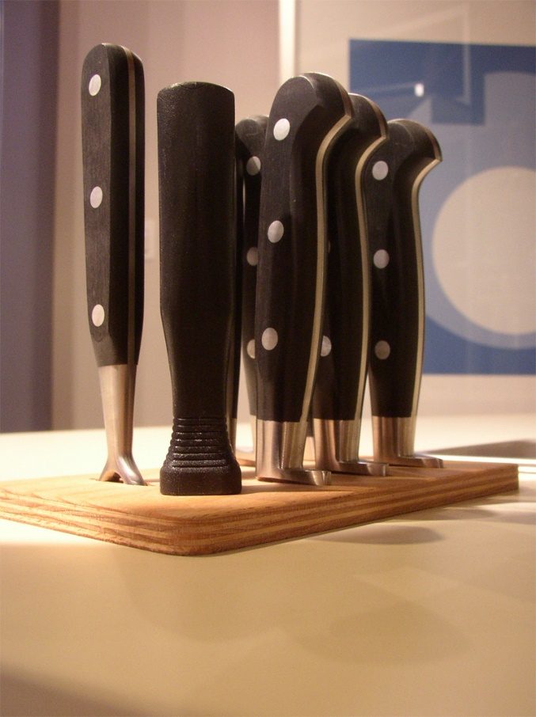

This form documents that the training specified above was presented to the listed participants. By signing below, each participant acknowledges receiving this training.

Organization: Date:

Trainer: Trainer’s Signature:

Class Participants:

Name: Signature:

Name: Signature:

Name: Signature:

Name: Signature:

Name: Signature:

Name: Signature:

Name: Signature:

Name: Signature:

Name: Signature:

Name: Signature:

Name: Signature:

Name: Signature:

Name: Signature:

Name: Signature:

Name: Signature:

Name: Signature:

