As part of a series on the role of the Safety Coach, this article focuses on observing work practices in the context of a behavior-based safety approach. Simply put, behavior-based safety (BBS) is a systematic way to promote safety in the workplace. Typically it involves creating a process that clearly defines a set of safe behaviors and work practices that reduce employees’ risks for injuries.


Behavior Based Safety:
- The behavior-based process provides a methodology to identify and reinforce safe work practices consistently and on a regular basis so these behaviors occur more frequently than at-risk behaviors.
- Ideally, in an effective BBS program, at-risk behaviors are reduced to a near-zero level. Using this approach, supervisors and co-workers conduct observations on the practices within their own work units in order to create and implement a coaching strategy that is customized to their organization’s needs.
- Making observations is critical in a BBS system. Observations provide the objective data that make behavioral coaching uniquely effective.
Observing behavior:
- Observations can be built around a checklist or Job Hazard Analysis (JHA) completed for a task or position. (These observations can come directly from one of the applications in Risk Management Center.)
- These documents ensure that important safety practices are considered.
- Use of these documents also helps the coach to be objective, specific and positive when discussing observations with the employees being observed.

Points to keep in mind when developing an observation checklist or Job Hazard Analysis:

The checklist: Take into consideration that checklists can have a variety of formats; the goal is to develop a format that is reliable and user-friendly.

Determining critical safe behaviors and practices: Deciding which employee practices to include on the checklist or JHA is a balance between including those essential to maintaining a safe workplace and creating a simple and easy-to-use tool. This is fairly straight forward for those organizations that use tools like JHAs.

Identifying practices: Practices included on the checklist or JHA must be described in such a way as to allow coaches to reliably record their observations. Each item must be detailed enough that the checklists or JHA of two independent observers, observing the same employee at the same time, will substantially be the same.

Trying out the checklist/JHA:

- Designing a valid, reliable, and above all else, practical checklist or JHA requires taking them out into the work place.
- Members of the work team can test the drafts of the JHA in their work areas.
- Ideally, the observation and recording of observations takes no more than fifteen minutes for each observation period.
- Observations should be performed during all aspects of the work that is done during the day, not only done for specified time periods.
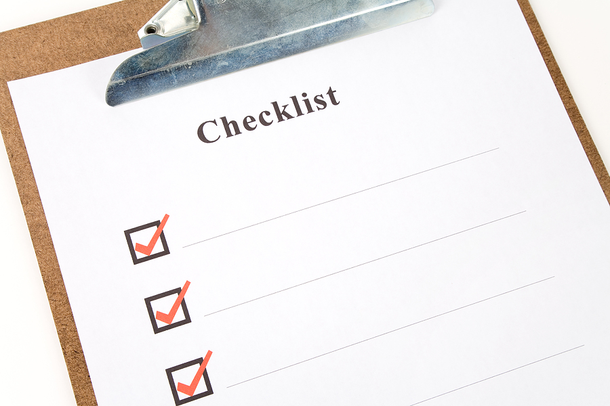

Observations on a regular basis can fine tune behaviors and provide the
data a safety coach needs to make improvements in their organization.

This form documents that the training specified above was presented to the listed participants. By signing below, each participant acknowledges receiving this training.

Organization:

Trainer: Trainer’s Signature:

Class Participants:

Name: Signature: Date:

Name: Signature: Date:

Name: Signature: Date:

Name: Signature: Date:

Name: Signature: Date:

Name: Signature: Date:

Name: Signature: Date:

Name: Signature: Date:

Name: Signature: Date:

Name: Signature: Date:

Name: Signature: Date:

Name: Signature: Date:

Name: Signature: Date:

Name: Signature: Date:

Name: Signature: Date:

Remember to load your completed trainings into the Risk Management Center.

