Forklifts are commonly used in numerous work settings, primarily to move materials. A forklift operator must be knowledgeable and committed to safety rules and policies to keep the workplace safe.

Training:
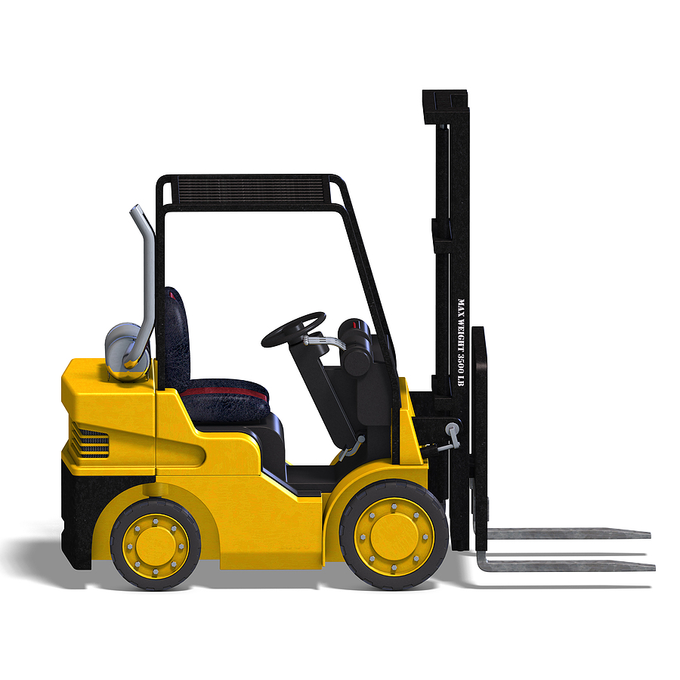
Familiarize yourself with the manufacturer’s user instructions, and take all necessary training. Operator certification is required and records must be available for inspection.

Pre-operational planning:
- A pre-operational equipment inspection checklist must be completed. Unsatisfactory equipment needs to be taken out of service.
- Travel routes must be determined prior to operation, and the affected employees need to be notified.
- The capacity of the forklift and the size of the load must be determined prior to operation.

Vehicle preparation:
- The owner’s manual should be kept on the forklift at all times.
- Rated limits must be visible on the lift. These must not be exceeded.
- Ensure that you are in the designated area for operating the forklift.
- If indoors, ensure that there is adequate ventilation for the use of an internal combustion engine.
- Secure or tie down unstable loads before starting the vehicle.

During the operation:
All of the manufacturer’s user instructions are to be strictly followed, including seat belt use. In addition, follow these guidelines:
- Loads must be down while the forklift is in motion.
- Tilt the mast back slightly before traveling.
- Ensure that there is adequate clearance before passing under or between structures.
- Maintain an indoor speed under 2 mph and an outdoor speed under 15 mph.
- Reduce speed when making turns and when going up or down ramps.

During the operation (continued):
- Driving in reverse:
- Drive in reverse when the operator’s forward vision is obscured. The best practice is to reduce the size of the load so the lift can be driven forward without an obscured view.
- Always have a backup alarm and honk the horn prior to reversing the lift.
- Maintain a safe distance from any hazards such as power lines or unstable ground.

Things that should never be done when operating a forklift:
- Do not ignore safety recommendations in order to finish a job more quickly.
- Do not exceed the forklift’s rated capacity or speed.
- Do not drive a forklift with an elevated load.
- Never operate a forklift without training and certification.
- Never let anyone other than the driver ride the forklift.
- Never leave an elevated load unattended.
- Never make turns on ramps.
- Never operate a forklift outside designated areas.
- Never ride on or under the load!
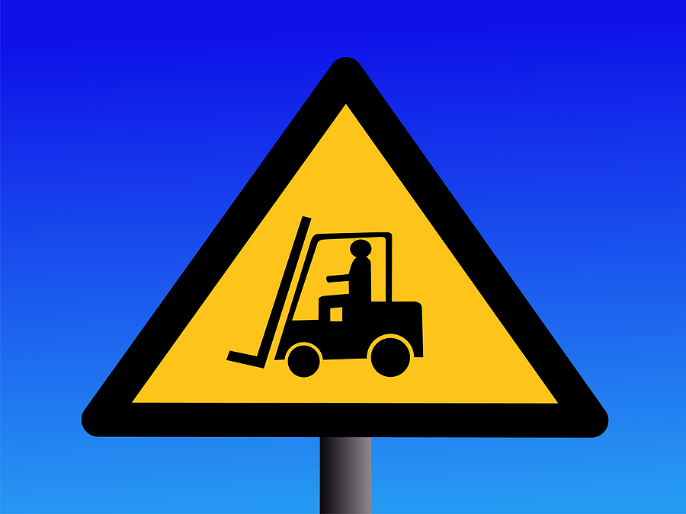

Your attitude and approach to forklift operation is the key to
your safety and that of your fellow co-workers.

This form documents that the training specified above was presented to the listed participants. By signing below, each participant acknowledges receiving this training.

Organization:

Trainer: Trainer’s Signature:

Class Participants:

Name: Signature: Date:

Name: Signature: Date:

Name: Signature: Date:

Name: Signature: Date:

Name: Signature: Date:

Name: Signature: Date:

Name: Signature: Date:

Name: Signature: Date:

Name: Signature: Date:

Name: Signature: Date:

Name: Signature: Date:

Name: Signature: Date:

Name: Signature: Date:

Name: Signature: Date:

Name: Signature: Date:

Remember to load your completed trainings into the Risk Management Center.

