The potential for injury from commonly used hand tools is always present.
Often these tools become so much a part of the job that we take them for granted. Certainly a broken tool can prove to be a hazard, but so can using the wrong tool for the job or failing to recognize the other hazards that can develop while using common hand tools.
Hand tools by definition are not powered by a secondary source. They rely on the force, strength and skill of the user to function properly. In order to do that safely, they need to be in good working order.
Did you know that each employer is responsible for the safe condition of tools and equipment used by employees, including tools and equipment which may be furnished by the employee?
Many potential injuries are associated with using simple hand tools:
- Strain, sprains and overexertion
- Cumulative trauma injuries
- Foreign objects in the eyes
- Hand or body injuries
- “Struck-with” or “struck-by” injuries
- Lacerations and punctures
Many hand tools are used on virtually any job. Here are a few common types:
- Wood working tools such as chisels
- Pounding tools such as hammers
- Digging tools such as shovels
- Cutting tools such as pruning loppers
- Mechanical tools such as adjustable jaw wrenches
- Various types of hand saws, rakes and pliers

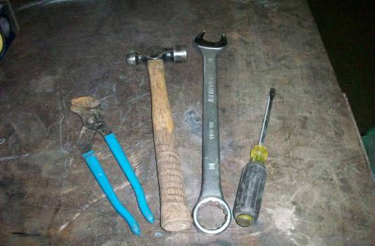

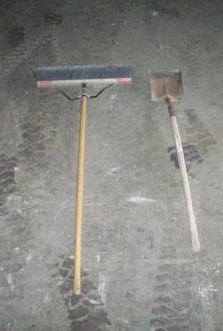
Before use:
Regardless of the type of tool, all hand tools should be inspected before they are used. Even employee-owned tools used on a job site should be inspected before use. Damaged, bent or defective equipment should not be used.
- Handles should be inspected for cracks:
- They should not be painted, lacquered or covered up with tape or material that prevents adequate inspection.
- Jaws should be in good shape, not loose, worn or stripped.
- Blades should be sharp and in good condition.
- Striking surfaces should be solid and free of worn
edges or mushrooming that could create a flying
debris hazard.
- Certain equipment requires ANSI or other certifications; non-approved tools should not be used in place of the approved equipment.
During use:
- Follow the instructions. Hand tools are designed to be used under particular manufacture-specified conditions and only used for the intended purpose.
- Never use “cheater bars,” extension handles, power equipment, or other non-approved alterations.
- Make sure you are not going beyond what the manufacturer intended by making variations on either the equipment or its use.
- Many accidents and injuries occur when the wrong tool is selected for a specific task. Common occurrences include:
- Using screwdrivers as chisels or as pry-bars.
- Using wrenches as hammers.
- Using loppers instead of a pruning saw on larger branches.
Personal protective equipment (PPE):
- Proper use of any hand tool includes considering the personal protective equipment (PPE) needed while using the tool.
- In many cases safety glasses or gloves should be used.
- With exposed blade cutting equipment, chaps or other cut-resistant material should be considered.
- One of the best examples of eliminating the hazard is the new style of razor knife that eliminates the possibility of people cutting themselves.
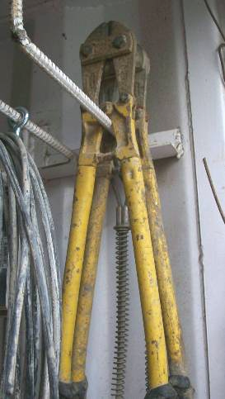

There are other potential hazards that can impact the type of PPE to be used:
- The type of PPE required may be altered by the presence of:
- Electricity
- Spring energy
- Compressed air
- Chemicals
- Fluids
- Heat or cold
- A person working during a warm summer day may need different types of PPE than a person working on a cold winter day, even though they are using the same tools and performing the same tasks.
- In some cases the PPE may require that a different tool be selected or that considerations be made for other pertinent hazards depending on the conditions that are encountered.
Ergonomics must be considered:
- The conditions or tasks to be performed may require the worker to hold the tool in an awkward position:
  - This may create a hazard in and of itself, or it may make the worker more susceptible to other hazards such as falls or potential damage to knees or other body parts.
- Another common problem with the use of hand tools can be repetitive motion issues that can produce cumulative trauma disorders.
- One of the more common occurrences of this condition is when framers and roofers repeatedly swing a hammer in the course of a day.
- Many great new tool designs have been developed to reduce this type of injury in the workplace:
  - Hammers with more ergonomically designed handles are now available.
  - The amount of force required to properly use some of these new, more ergonomically designed tools is also considerably less.
Hazard Assessments:
- Employers need to perform hazard assessments in their workplaces to characterize the nature and types of hazards that are present.
- They are simple and do not have to be cumbersome.
- Consider the types of tools that will be used, the conditions that will be experienced and the type of personal protective equipment that may be needed.
- Hazard assessments should be in writing and specific for the job or task to be performed.

This form documents that the training specified above was presented to the listed participants. By signing below, each participant acknowledges receiving this training.

Organization:

Trainer: Trainer’s Signature:

Class Participants:

Name: Signature: Date:

Name: Signature: Date:

Name: Signature: Date:

Name: Signature: Date:

Name: Signature: Date:

Name: Signature: Date:

Name: Signature: Date:

Name: Signature: Date:

Name: Signature: Date:

Name: Signature: Date:

Name: Signature: Date:

Name: Signature: Date:

Name: Signature: Date:

Name: Signature: Date:

Name: Signature: Date:

Remember to load your completed trainings into the Risk Management Center.

