As drivers, we must do all we can to prevent accidents: If you are in an accident, you should know what to do so the situation is not made worse. Your actions should be almost automatic.

- Make sure to report the accident: No matter who is responsible, every vehicular accident must be reported at once. It is a criminal offense to leave the scene of any accident before identifying yourself.
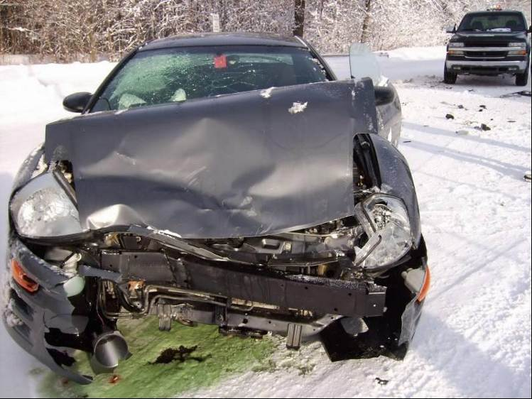
- Turn the vehicle off: If you are in an accident, turn off the ignition and try your best to stay off the road. Commercial drivers must comply with Motor Carrier Safety Regulations and set up reflective triangles and flags or flares.

- Stay at the scene of the accident: Stay until someone relieves you, unless you need medical attention or go to call for help.

- Call the appropriate people: Call the police and your home and or office immediately.

- Collect information: Get the license numbers of all vehicles involved and the names and addresses of all drivers and passengers. If there has been any property damage, get the name and address of the owner or owners. List the companies that insure the property and vehicles. Try to get the names and addresses of anyone at the scene, whether they actually saw the accident or not.
- Do not argue or discuss fault: People are usually emotionally upset at an accident and will argue without making much sense. Arguing only prevents you from getting the facts down on paper. A good driver sets a good example by his or her behavior at the accident scene. One should be calm and businesslike.

- Search for the owner: If the accident involves an unattended vehicle, do a reasonable search for the owner. If the owner cannot be found, leave a note in a conspicuous place, so they can contact you. Inform the police and ask if they want you to remain at the scene.

- Don’t move injured victims: Never move injured victims unless it is absolutely necessary to get them away from fire or passing traffic. Moving them can easily make their condition worse, especially if they have internal injuries. If there are injuries, call 911 immediately. Give first aid, but only if you are certified and confident in what you are doing.
- Keep other people away: If people gather around, help keep them away from the victims and accident scene so as not to destroy any of the evidence e.g., skid marks and parts of vehicles. Keep everyone away from spilled fuel or other materials – a careless cigarette toss can turn a minor accident into a major one.
- Take pictures: If you have a camera, take several pictures from different angles including the directions from which the vehicles approached the accident location.
- Make a record: As soon as time is available, write an account of the accident as it looked to you. Fill out all required incident investigation forms and insurance reports. Such reports may seem like a burden at the time, but your description can be the basis for preventing such accidents in the future.
Above all, be prepared and be thoroughly familiar with your organization's policies and procedures regarding accidents.
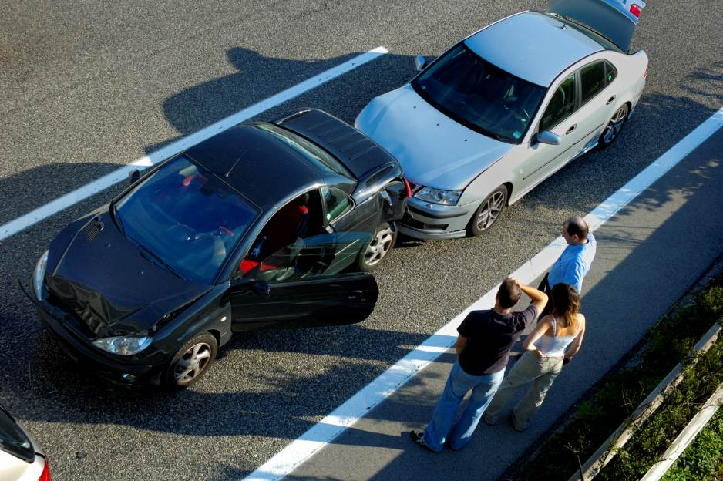
This form documents that the training specified above was presented to the listed participants. By signing below, each participant acknowledges receiving this training.

Organization:

Trainer: Trainer’s Signature:

Class Participants:

Name: Signature: Date:

Name: Signature: Date:

Name: Signature: Date:

Name: Signature: Date:

Name: Signature: Date:

Name: Signature: Date:

Name: Signature: Date:

Name: Signature: Date:

Name: Signature: Date:

Name: Signature: Date:

Name: Signature: Date:

Name: Signature: Date:

Name: Signature: Date:

Name: Signature: Date:

Name: Signature: Date:

Name: Signature: Date:

Name: Signature: Date:

Remember to load your completed trainings into the Risk Management Center.

