Only 1/3 of all driving is done after dark, but 2/3 of all fatal accidents happen at night.
One obvious problem associated with night driving is limited vision. With only your headlights to show your way, you are boxed into a visual area that extends only about 300 feet in front of you. If an object ahead is a dark color or does not reflect your headlights, you may not see it until it is too late to react safely.
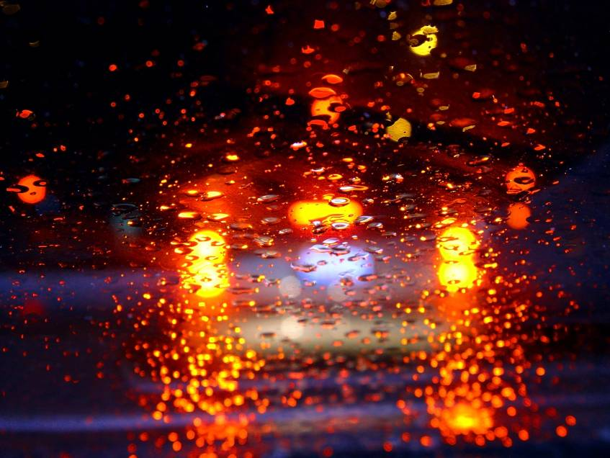
Your eyes do not process information as well:
- At dawn
- At dusk
- In dark conditions

Your eyes get fatigued by continually adjusting to rapidly changing distances and conditions. Drivers cannot judge distances as well when it is dark. Objects that, in daylight, help you relate to other objects cannot always be seen.
Dirty windshield at dusk
Keep your windshield as clean as possible:
- Vision is especially impaired at night, dawn and dusk conditions.
- A light film of dirt can reduce your ability to see by as much as 40 percent.
- Dirty windshields also create glare, further impairing vision.
Consider other drivers and drive defensively:

- Remember that approaching traffic has similar driving conditions.
- Lower the beam of your headlights when you see an oncoming vehicle. The driver of the approaching vehicle may be blinded by your high beam lights.
- If the other driver doesn't dim his or her lights, divert your view to the lower right side of the road in front of you to avoid being affected by the glare.
- Take curves more slowly at night. Your headlights point straight ahead and, thus, do not illuminate what is around each corner. “Expect the Unexpected” around each blind-spot!
- Take extra care during the half-light of dawn and dusk. At those times, headlights may not be enough to give you a clear view. Additionally, the glare of the rising or setting sun may blind you or other drivers. Drive carefully when traveling into or away from a low sun.
This form documents that the training specified above was presented to the listed participants. By signing below, each participant acknowledges receiving this training.

Organization:

Trainer: Trainer’s Signature:

Class Participants:

Name: Signature: Date:

Name: Signature: Date:

Name: Signature: Date:

Name: Signature: Date:

Name: Signature: Date:

Name: Signature: Date:

Name: Signature: Date:

Name: Signature: Date:

Name: Signature: Date:

Name: Signature: Date:

Name: Signature: Date:

Name: Signature: Date:

Name: Signature: Date:

Name: Signature: Date:

Name: Signature: Date:

Name: Signature: Date:

Name: Signature: Date:

Remember to load your completed trainings into the Training Track application of the Risk Management Center.

