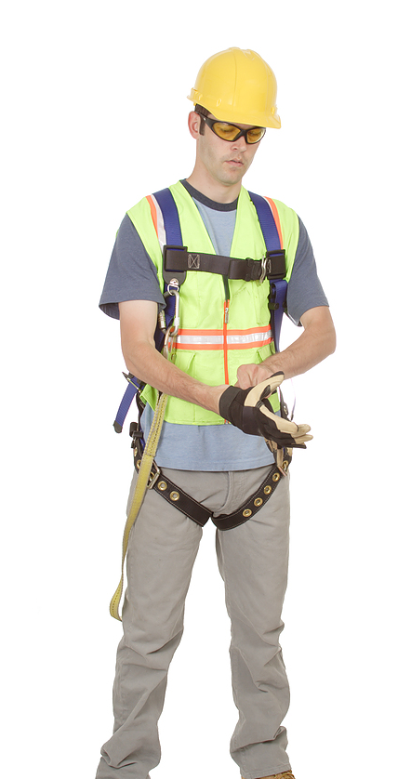
Safety harnesses may be required when working at elevated heights as part of a fall protection system. Only full body harnesses are allowed to be used as fall protection, not body belts. Also note that harnesses must be made out of synthetic material.
Follow all training regarding the use, fit, inspection, donning, and care of the harness, as your life may depend on its effectiveness.
Prior to putting on your harness:
- Inspect and test your harness and hardware carefully before use to assure that there are no defects such as fraying, holes, cuts, or other deterioration or weakness.
- Take equipment out of service whenever you suspect defects or problems. When in doubt, err on the side of caution.
For your own protection, take good care of your safety harness:
- Handle your harness with care:
- Never drop it on the ground.
- Keep it away from sharp tools or other objects which might scratch or cut it.
- Never weaken the harness or its strap by cutting or punching extra holes.
- Protect the harness from hazardous materials:
- Do not permit acids, caustics or other corrosive materials to get on the harness.
- Paint and coatings may compromise the integrity of the harness by restricting movement and potentially causing chemical damage.
- Take care when washing or drying the harness:
- If needed, wipe off a soiled harness with warm water and mild soap. Rinse with warm water.
- Wipe a wet harness with a clean dry cloth and let it dry slowly at a temperature no higher than your hand can bear.
- Do not expose a wet harness to extreme cold, heat, or sunlight.
- Replace harnesses as needed:
- If the harness is accidentally cut or damaged, turn it in for repair or salvage.
- Any safety harness subjected to in-service loading, such as a fall, needs to be removed from service.
- Replace harnesses, following the manufacturer’s instructions and timeline.
- Store harnesses safely: Store harnesses in separate, dry compartments or hang them so that they will not be crushed, worn, or creased.

The number one cause of injury on the work place is falls where
employees are not wearing the appropriate fall protection system.
This form documents that the training specified above was presented to the listed participants. By signing below, each participant acknowledges receiving this training.

Organization:

Trainer: Trainer’s Signature: _____

Class Participants:

Name: Signature: Date:

Name: Signature: Date:

Name: Signature: Date:

Name: Signature: Date:

Name: Signature: Date:

Name: Signature: Date:

Name: Signature: Date:

Name: Signature: Date:

Name: Signature: Date:

Name: Signature: Date:

Name: Signature: Date:

Name: Signature: Date:

Name: Signature: Date:

Name: Signature: Date:

Name: Signature: Date:

Remember to load your completed trainings into the Risk Management Center.

