Inclement weather conditions can dramatically decrease visibility and increase the risk of accidents. Proper driving techniques and precautions can help prevent an accident in such conditions as rain, snow, ice and fog.

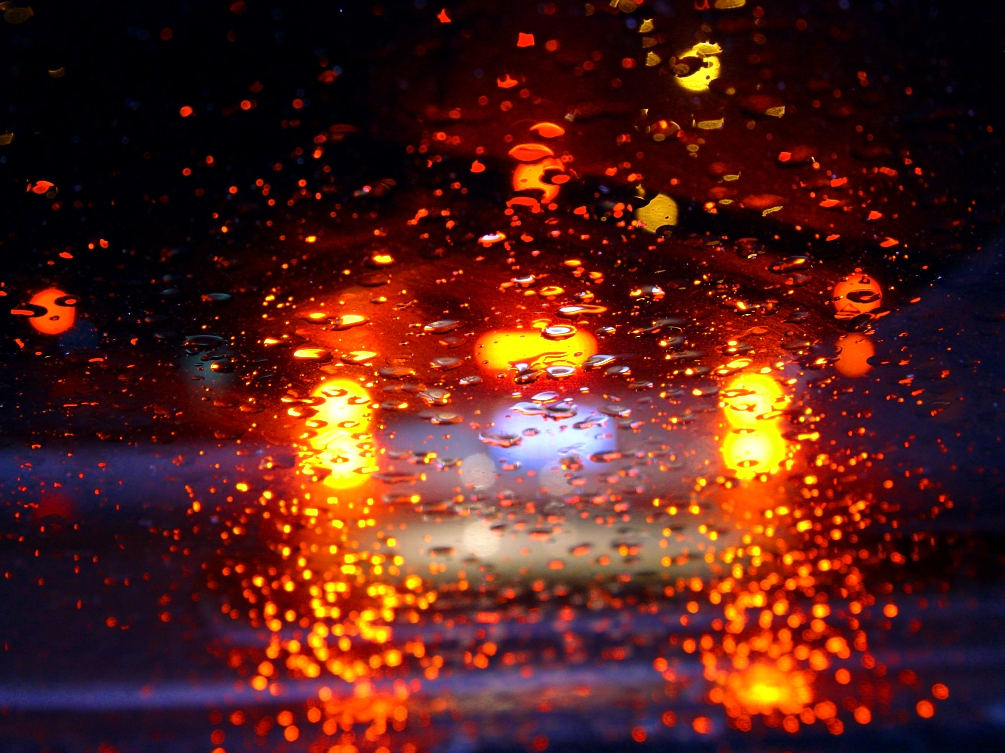
Driving in the rain:
- Check the vehicle wiper blades: Periodically check for deterioration and wear. Worn wiper blades can smear water and dirt, which can significantly decrease visibility.
- Check the lights: Make sure vehicle lights are in proper working order and are always on during poor weather conditions. Headlights should always be on when windshield wipers are operating.
- Check the tires: Tires are a critical part of the vehicle. Regularly check that tires are inflated to manufacturers’ recommended levels and have sufficient tread depth. Assure you have the proper tires for the road conditions.
- Always allow for additional time: Do not rush to your destination in the rain. Hydroplaning is possible at speeds as low as 35 miles per hour.
- Do not use cruise control: If you begin to hydroplane, cruise control could cause you to lose control.
- Try not to cross pools of standing or running water: You do not know what hazards may be present beneath the water surface. Additionally, water can cause serious damage if it reaches the engine.
- Brake early: Use brakes earlier to increase your following distance and to notify other drivers that you are slowing or stopping.
- Exercise extreme caution: Dirt on roadways can become extremely slippery when wet, especially immediately after a long dry period.
- Increase your following distance: Following the guidelines in “Driving Safety for Non-Commercial Drivers,” increase your following distance when driving in rain or low-visibility situations.
- Avoid stopping on the shoulder of a roadway: In reduced-visibility situations, drivers tend to follow the tail lights of the vehicles in front of them. If you have to stop, use turn signals and emergency warning devices.
- Watch out for pedestrians: The sound of rain can make it difficult for pedestrians to hear oncoming traffic.
- Defog your windows: Rain will quickly cause windshields to fog up. Switch on the front and rear defrosters prior to starting your trip.
- Plan accordingly: Watch weather forecasts and plan trips to avoid major storms.

Driving in snow and ice:
- Check the tires and traction devices: Make sure that tires have adequate tread depth and are the proper type of tires for the road conditions. Make sure that traction devices are in the vehicle, in good repair and used as needed. Know how to install chains on your vehicle and proper safety precautions for driving with chains.
- Assure that wipers and defrosting systems are functional: Wiper blades should be replaced if rubber is deteriorated or if streaking occurs.
- Keep your gas tank full: The extra weight will provide additional traction. Sand bags can also be used for additional weight.
- Use caution: Practice defensive driving techniques. Increase your following distance.
- Avoid abrupt stops: If your vehicle has antilock brakes, let them do the braking work. If your vehicle does not have antilock brakes, pumping the brakes will assist in stopping and minimize the possibility of losing control.
- Watch where you stop when it is icy: Do not stop at the top of icy hills if possible, as starting on icy inclines may be difficult.
- Stay clear of trucks: Avoid driving behind or near large trucks, as they may create visibility issues and have a harder time stopping.
- Do not attempt to make sharp turns: Plan ahead to make wider, slower turns. Avoid jerky movements and maintain a slow, comfortable speed.
- Watch for ice: When temperatures fall below 32˚F, damp or wet road surfaces can form ice. Drive with additional caution when approaching curves and other blind spots, as well as traveling on overpasses and bridges.
Driving in the fog:
- Turn your high beams off: When driving in the fog, do not drive with the high beams on. They will reflect off the fog and decrease your visibility even more.
- Use caution: Practice defensive driving techniques. Increase your following distance.
- Drive within your visibility range and headlights: Your stopping distance should not be greater than how far you can see ahead with your headlights.
Vehicle maintenance and preparation for weather conditions:
- Assure you have the right equipment: Assure that vehicles are equipped with proper equipment for expected weather conditions.
- Each vehicle should have emergency kits: The contents of these kits should include emergency flares, reflective triangles, tow ropes, jumper cables, a flashlight, first aid supplies and, as needed, cold weather emergency gear.
- Follow your vehicle’s preventive maintenance program: Perform daily pre-use and post-use walk-arounds. Check brakes, tire pressure, tread depth, defroster operations and all other required safety items as specified by the manufacturer and for regulated vehicles.

Do not use a vehicle unless it is safe and you are properly prepared and trained.

This form documents that the training specified above was presented to the listed participants. By signing below, each participant acknowledges receiving this training.

Organization:

Trainer: Trainer’s Signature: _____

Class Participants:

Name: Signature: Date:

Name: Signature: Date:

Name: Signature: Date:

Name: Signature: Date:

Name: Signature: Date:

Name: Signature: Date:

Name: Signature: Date:

Name: Signature: Date:

Name: Signature: Date:

Name: Signature: Date:

Name: Signature: Date:

Name: Signature: Date:

Name: Signature: Date:

Name: Signature: Date:

Name: Signature: Date:

Remember to load your completed trainings into the Risk Management Center.<is current font size correct?

