The menace of motion

Almost 200,000 workers are injured every year by machinery. This is third highest cause of occupational injury in the United States. The most common source of those injuries is workers being struck by or caught in moving parts.

There are essentially two kinds of motion in machinery… rotating and sliding:

- Rotating: Shafts rotate. Drill presses, rollers, pulleys, and gears spin. Rotating machinery and moving parts can grab loose hair, jewelry, and clothing.

- Sliding (or reciprocating): Power presses, shears, and other machine parts slide up and down or sideways with great force. These motions can pinch, crush, and chop misplaced fingers, hands, and arms.

Machines are everywhere, and are used by smaller facilities as well as the big and busy production facilities. Recognize and avoid the hazards of machinery wherever you are working.



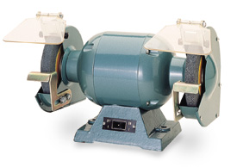

Important points to remember when working with machinery:

- Never operate a machine unless you are fully trained and authorized to use it.
- Only use a machine the way it is designed to be used and according to all the manufacturer’s safety requirements.
- Always ensure that all safeguards are in place and that everyone is clear of moving parts prior to use.
- Never reach into any hazard area or moving portion of a machine for any reason, such as removing a blockage, without first implementing proper Lockout/Tagout procedures.
- Always perform Lockout/Tagout when doing machine maintenance and repair. Always disconnect the main power, release all stored energy, and prevent re-energizing (lockout).
- Only use machines that are properly maintained and in safe working condition.
- Only operate machines when you are dressed properly (make sure there is no loose hair or clothing, or jewelry to catch in a machine).
- Always turn off the machines when you have finished using them.

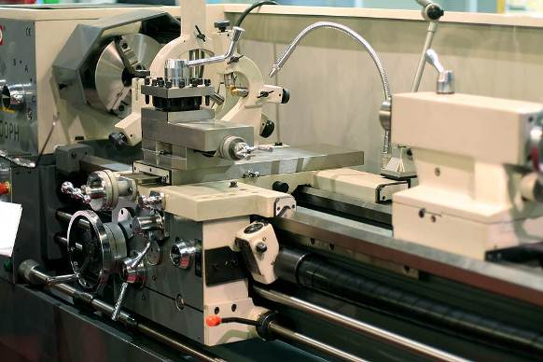
This form documents that the training specified above was presented to the listed participants. By signing below, each participant acknowledges receiving this training.

Organization:

Trainer: Trainer’s Signature:

Class Participants:

Name: Signature: Date:

Name: Signature: Date:

Name: Signature: Date:

Name: Signature: Date:

Name: Signature: Date:

Name: Signature: Date:

Name: Signature: Date:

Name: Signature: Date:

Name: Signature: Date:

Name: Signature: Date:

Name: Signature: Date:

Name: Signature: Date:

Name: Signature: Date:

Name: Signature: Date:

Name: Signature: Date:

Name: Signature: Date:

Remember to load your completed trainings into the Risk Management Center.

