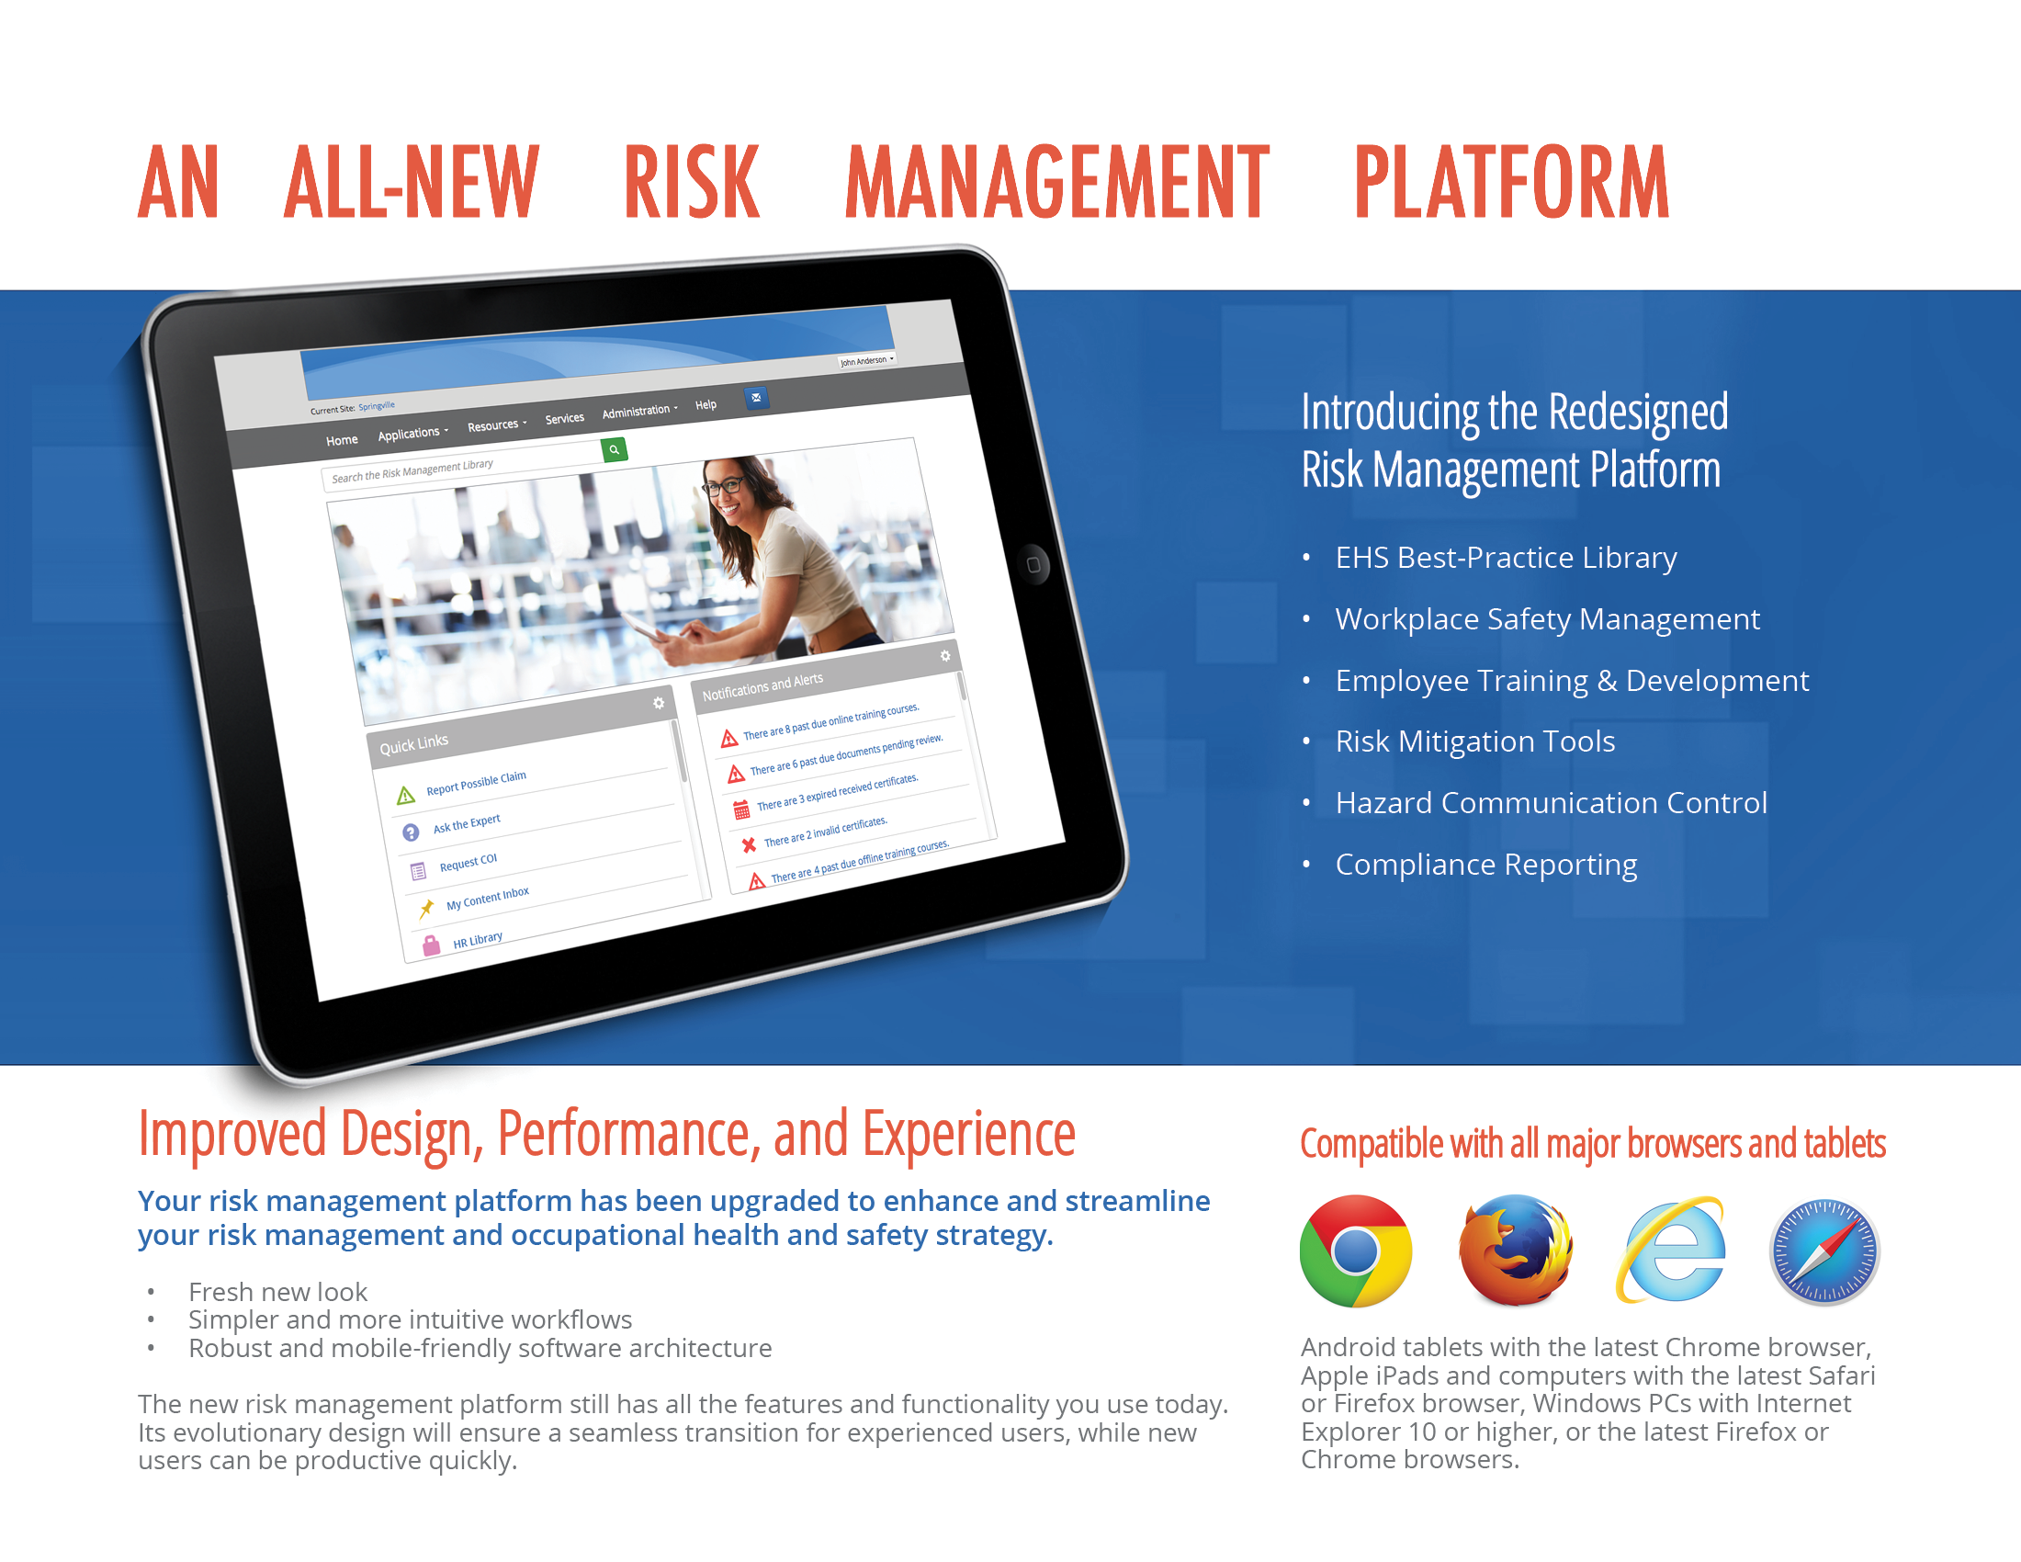

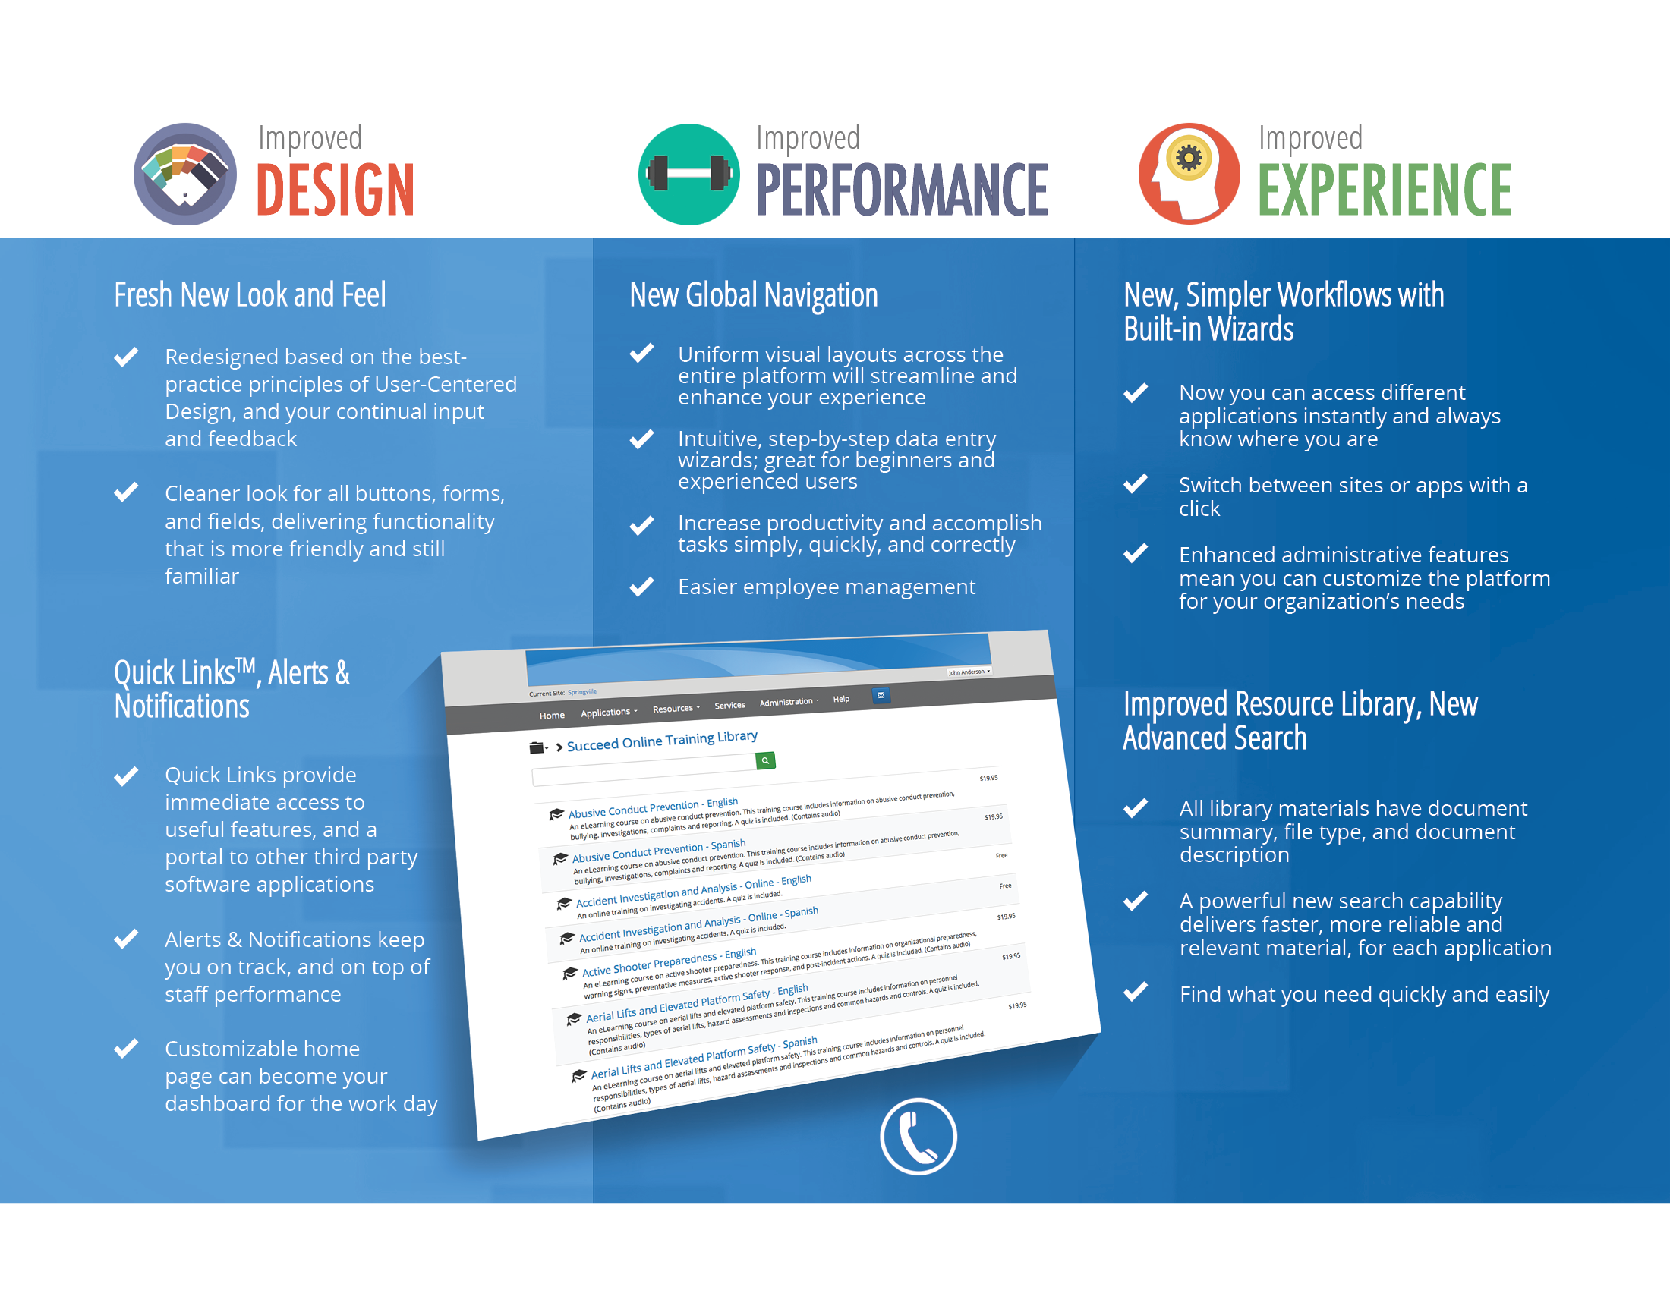

Video
Available Training

More Information
To learn more, or to sign up for a no-obligation webinar, contact your platform provider or Succeed Client Services at 503.766.6099 or clientservices@succeedms.com.

